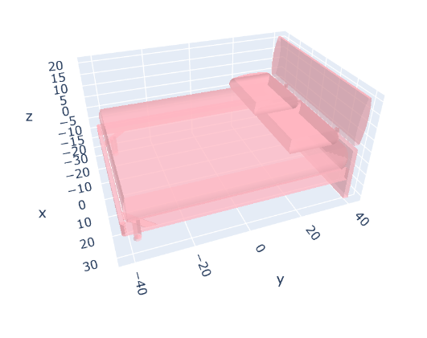

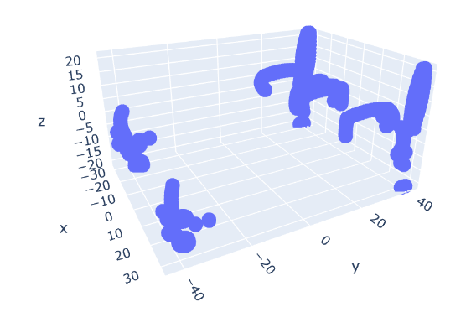

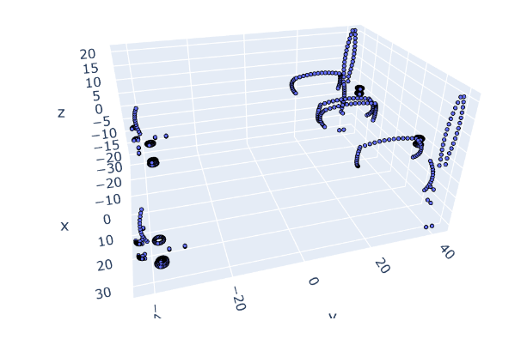

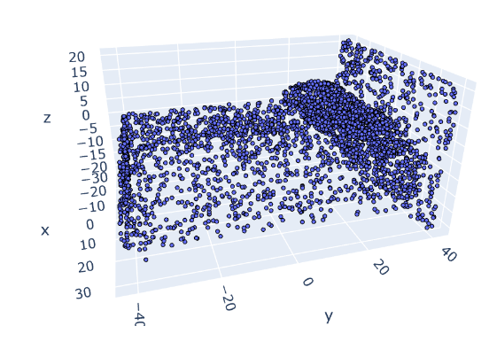

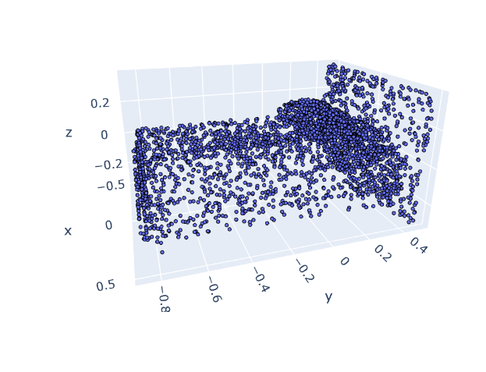

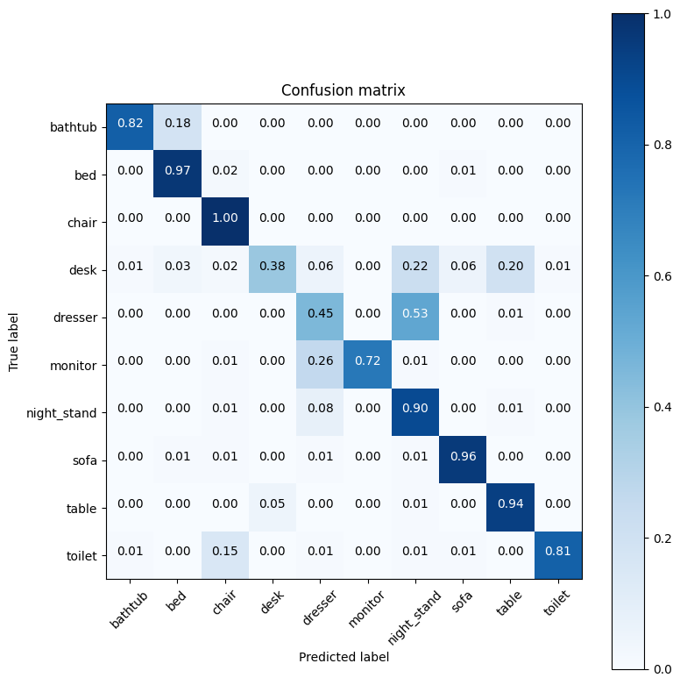

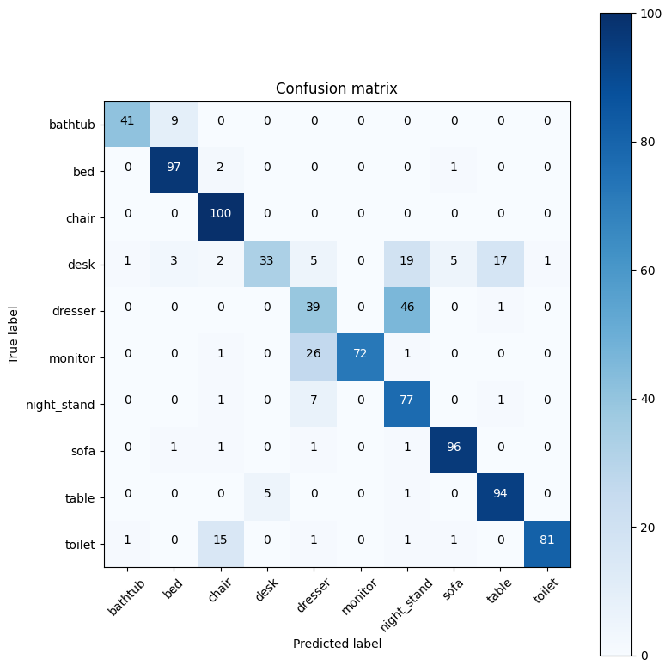

Object bathtub:

Accuracy: 0.8200

Precision: 1.0000

Recall: 0.8200

F1 Score: 0.9011

Object bed:

Accuracy: 0.9700

Precision: 1.0000

Recall: 0.9700

F1 Score: 0.9848

Object chair:

Accuracy: 1.0000

Precision: 1.0000

Recall: 1.0000

F1 Score: 1.0000

Object desk:

Accuracy: 0.3837

Precision: 1.0000

Recall: 0.3837

F1 Score: 0.5546

Object dresser:

Accuracy: 0.5000

Precision: 1.0000

Recall: 0.5000

F1 Score: 0.6667

Object monitor:

Accuracy: 0.7100

Precision: 1.0000

Recall: 0.7100

F1 Score: 0.8304

Object night_stand:

Accuracy: 0.9186

Precision: 1.0000

Recall: 0.9186

F1 Score: 0.9576

Object sofa:

Accuracy: 0.9600

Precision: 1.0000

Recall: 0.9600

F1 Score: 0.9796

Object table:

Accuracy: 0.9300

Precision: 1.0000

Recall: 0.9300

F1 Score: 0.9637

Object toilet:

Accuracy: 0.8400

Precision: 1.0000

Recall: 0.8400

F1 Score: 0.9130